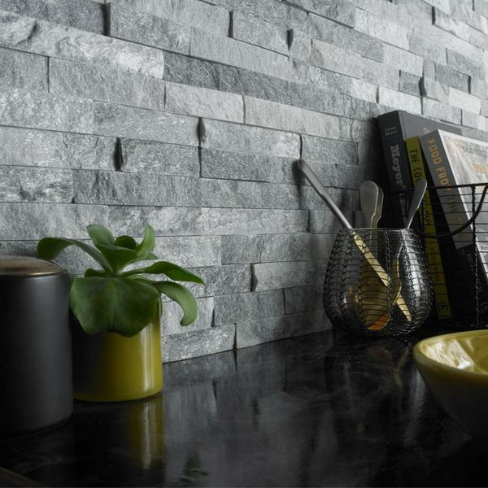

Crystal Arctic Grey: <https://www.wallsandfloors.co.uk/arctic-grey-tiles>

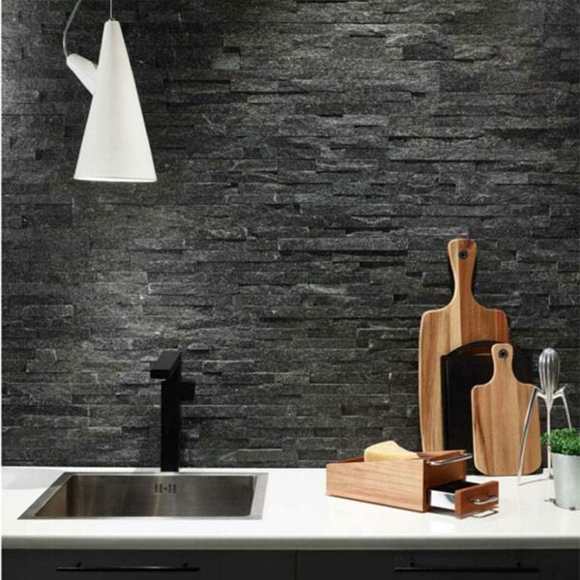

Crystal Cobalt Black: <https://www.wallsandfloors.co.uk/cobalt-black-tiles>

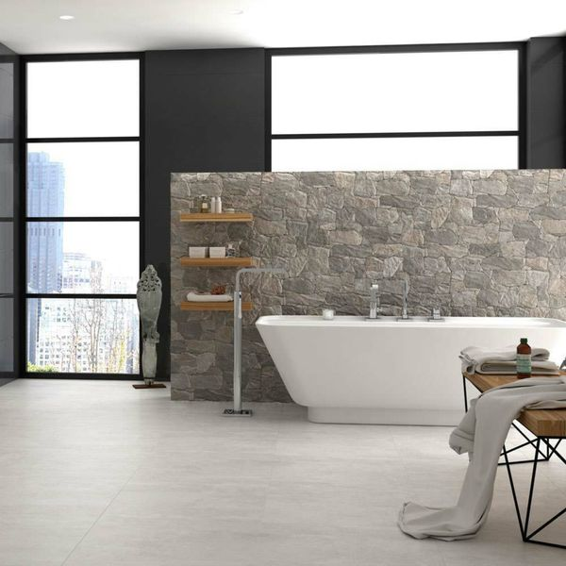

Stacked Iron Stone: <https://www.wallsandfloors.co.uk/cusco-stacked-iron-stone-effect-tilese>

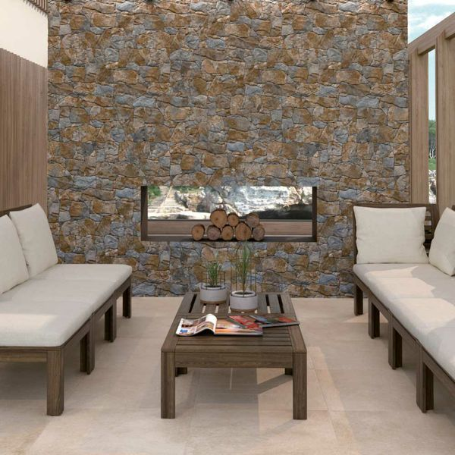

Stacked Rustic Slate Stone: <https://www.wallsandfloors.co.uk/cusco-dry-stone-wall-effect-tiles-stacked-rustic-slate-stone-effect-tiles>

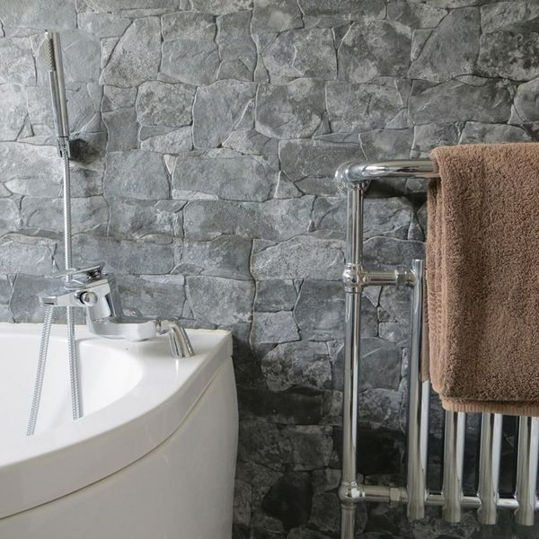

Stacked Slate Stone: <https://www.wallsandfloors.co.uk/cusco-dry-stone-wall-effect-tiles-stacked-slate-stone-effect-tiles>